PROJECT DEVELOPMENT
USER ACCEPTANCE TEST (UAT) DOCUMENT
Auto Ticket Classification using Flow Designer

PROJECT & TEAM DETAILS
Project Title | Auto Ticket Classification using Flow Designer
Team ID | SWTID-2026-8882
Team Size | 5
Team Leader | VIJAYALAKSHMI S
Team Member | TAMILMANI K
Team Member | UTHAYAMALIYA K
Team Member | VAISALI G
Team Member | Vishalini S

1. TESTING OBJECTIVE
To verify from the end-user perspective that the automated ticket classification workflow satisfies the agreed business and functional requirements.
2. TESTING SCOPE
- User creates ticket
- Automatic classification
- Result verification
- User feedback
- Acceptance
3. TESTING WORKFLOW
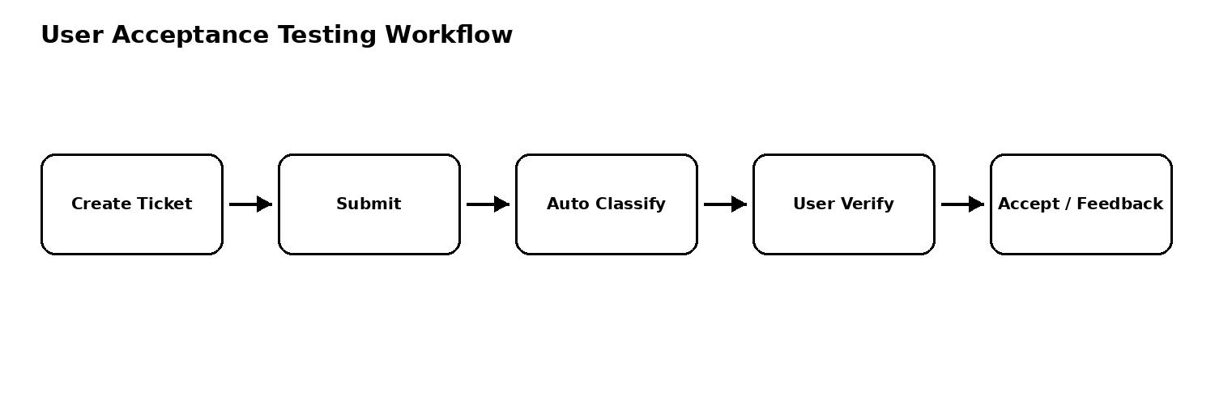
4. USER ACCEPTANCE CRITERIA
- Users can create/submit a ticket with required information.
- The system automatically classifies tickets using configured business rules.
- Classification is visible in relevant ticket fields.
- Unmatched/incomplete inputs follow the defined handling path.
- The workflow result is understandable and usable by intended users.
5. ACCEPTANCE PROCESS
- Provide UAT scenarios to stakeholder/user.
- Demonstrate ticket creation and automatic classification.
- Ask user to verify category and related fields.
- Record feedback, defects, and change requests.
- Obtain final sign-off after agreed issues are resolved or documented.
6. UAT ACCEPTANCE STATEMENT
The solution is considered accepted when the agreed user scenarios are completed successfully and the stakeholder confirms that the demonstrated workflow meets the defined project requirements.
6. TEST CASES / ACCEPTANCE SCENARIOS
ID | Scenario | Input / Action | Expected Result | Status
UAT01 | Create a support ticket | Enter valid ticket information and submit | Ticket is created successfully | PASS
UAT02 | Automatic classification | Submit ticket matching a configured rule | Correct classification is assigned automatically | PASS
UAT03 | Verify ticket fields | Open processed ticket | Expected classification fields are visible and correct | PASS
UAT04 | Unmatched ticket | Submit ticket matching no configured rule | Defined default/unmatched handling is applied | PASS
UAT05 | End-to-end user scenario | Create and review complete ticket | User completes scenario and understands result | PASS
7. TEAM RESPONSIBILITIES
Role | Name | Responsibility
Team Leader | VIJAYALAKSHMI S | Coordinate UAT session
Team Member | TAMILMANI K | Guide ticket creation
Team Member | UTHAYAMALIYA K | Explain workflow behavior
Team Member | VAISALI G | Verify acceptance results
Team Member | Vishalini S | Collect feedback and final sign-off
8. RESULT / SIGN-OFF
Overall Result: ____________________
Remarks: __________________________________________________________________
Approved By: ________________________ Date: __________________

